**Postman UI**

API's tested in local/QA environment whereas API's moved to production once they are available on the web - Web Services Testing

**All API's are not webservices but All webservices are API's**

Types of Web Services -

SOAP (Simple Object Access Protocol) - Old Technology - Only Post is Supported - Only XML format is supported

and RESTful (Representational Sate Transfer) - New Technology - All 4 requests are supported - Supports different formats

**HTTP Requests-------------------**

Get - Select - Get you the data from the server

Post - Insertion/Creation - It'll go and create a new resource/record in the server - need to pass Request Body or Request Payload

Put - Updation - update the record - needs to pass request payload

Delete - Deletion - pass the URL and that will delete the record

**Every request will get you response in json/xml/text format**

------------------------------------

*https://reqres.in/api/users?page=2 ------Uniform Resource Locator (URL)*

*https://reqres.in ----- Domain*

*/api/users ---- Path Parameters - will get the data from server*

*?page=2 ----- Query Parameters - will filter the data from server*

----------------------------------------------------------------------

***GET - Once we send request then we need to validate response body, status code(200,201- successful), TIme , Data size and***

*every response will have Headers also need to validate headers*

***To add validation points, click on Tests tab***

*tests["validating status code"]= responseCode.code== 200; ---- this is a javascript code to validate status code*

*tests["validating response body"]= responseBody.*

*has("Howell"); ----- this is to validate the Response Body in the entire body*

*var response = JSON.parse(responseBody);*

*tests["per_page"] = response.per_page==6; ---- this is used to validate particular header like page,per_page,total etc…*

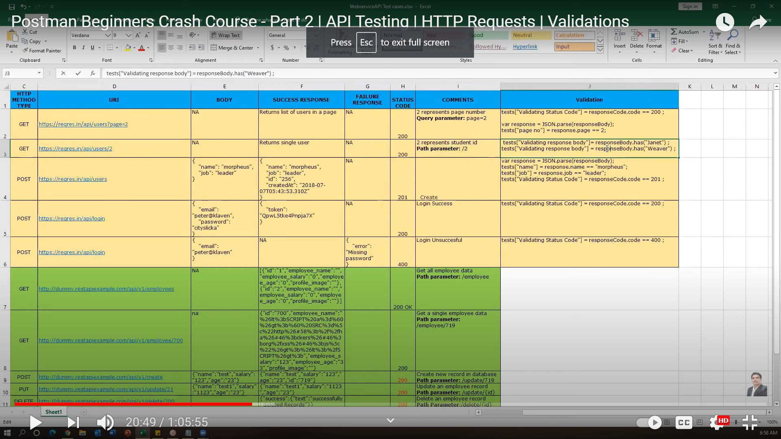

**To validate first_name and last_name from the response body**

*tests["validating response body"]= responseBody.has("Janet");*

*tests["validating response body"]= responseBody.has("Weaver");*

***This is not recommended as the above check just validates the entire response and gives the pass/fail status instead our target is to validate precisely first_name and last_name***

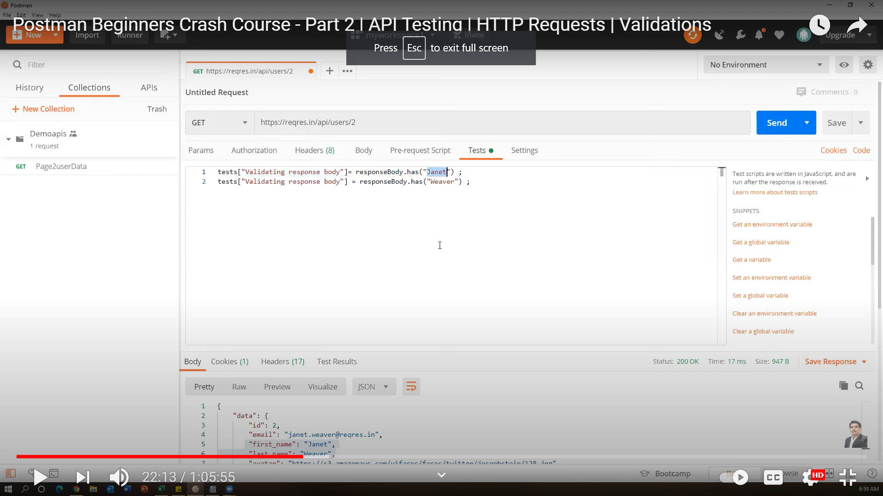

***Preferred:***

***var response = JSON.parse(responseBody);***

***tests["verify first_name"] = response.data.first_name == "Janet";***

***tests["verify last_name"] = response.data.last_name == "Weaver";***

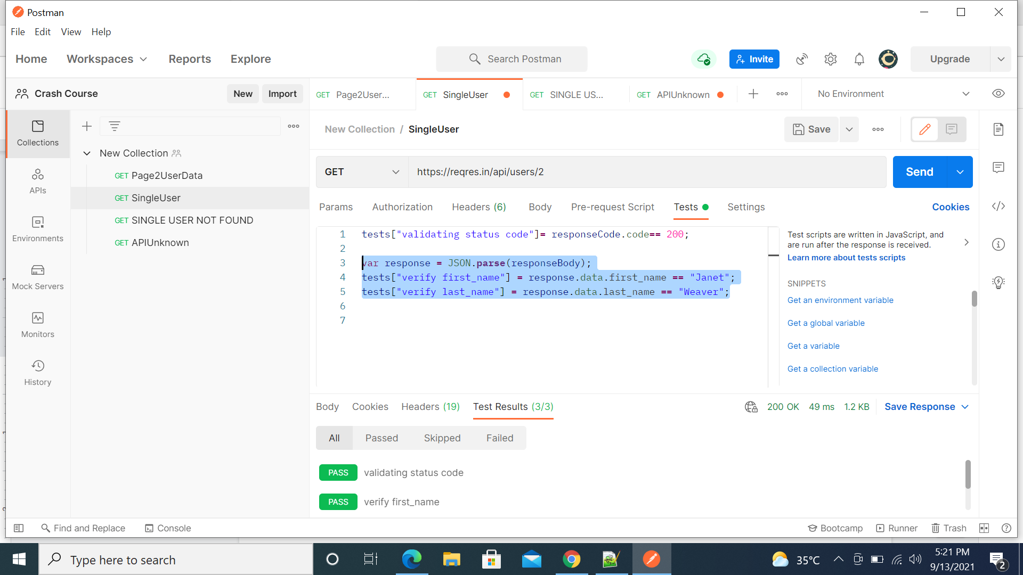

**JSON PATH FINDER - will provide the input and output format of json values to be set while validating the test**

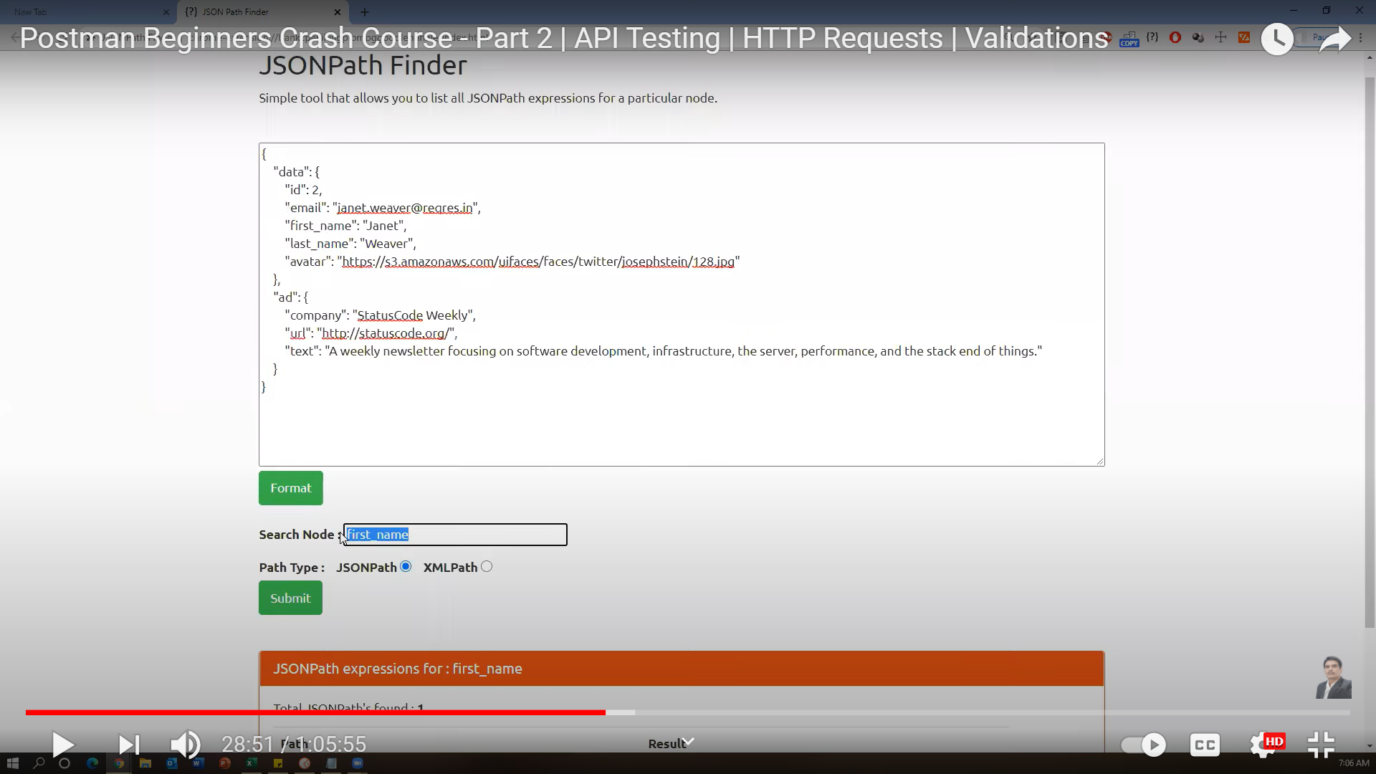

**POST - Pass Request body in the Json format and it will create a new record in the database**

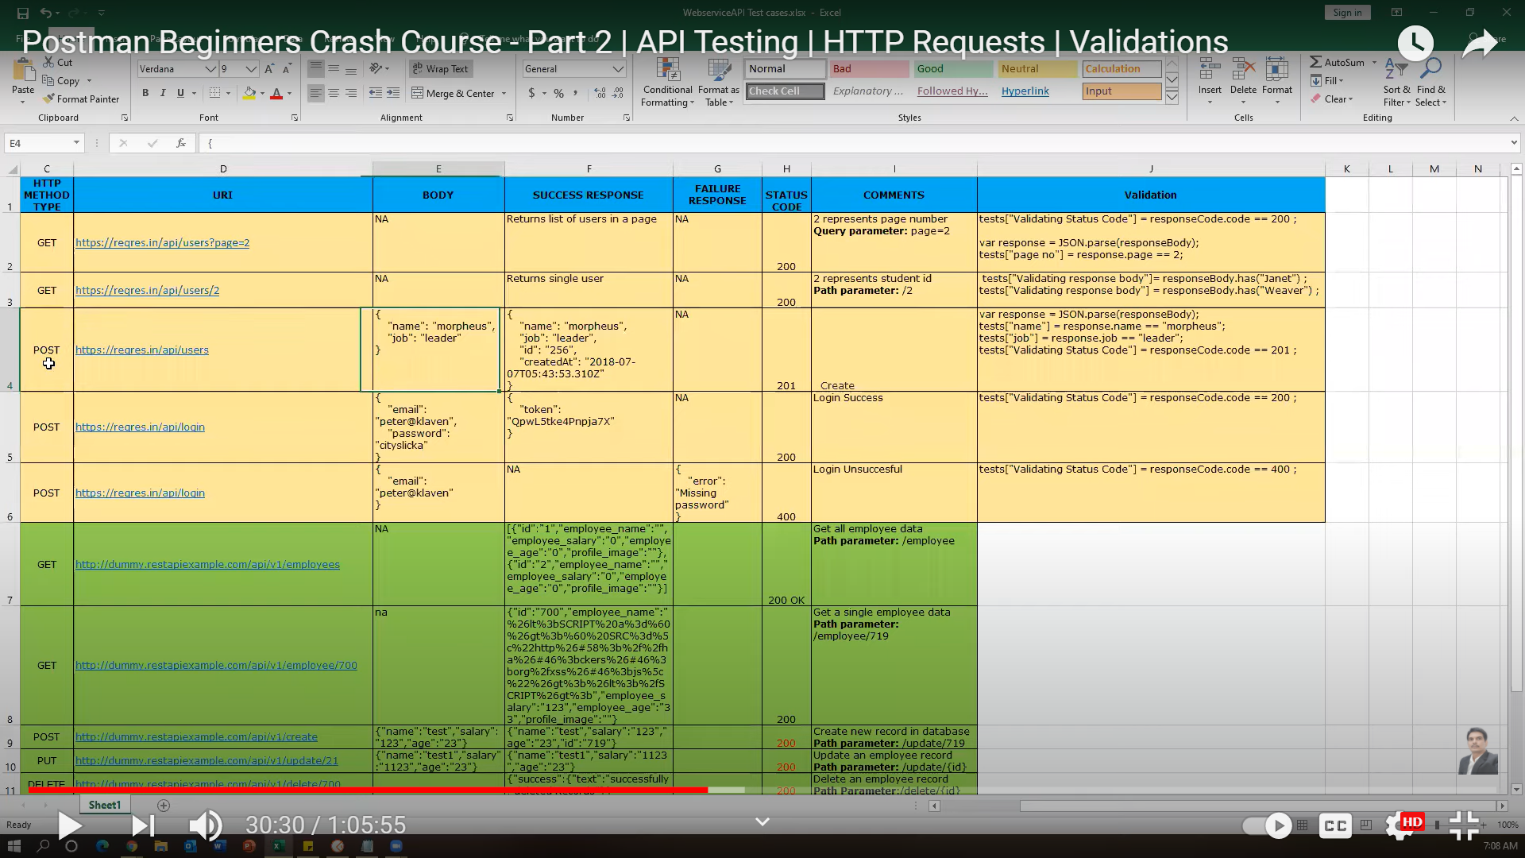

In the Body, we need to send the data and once the response is created then we need to validate timestamp,id and status code as 201

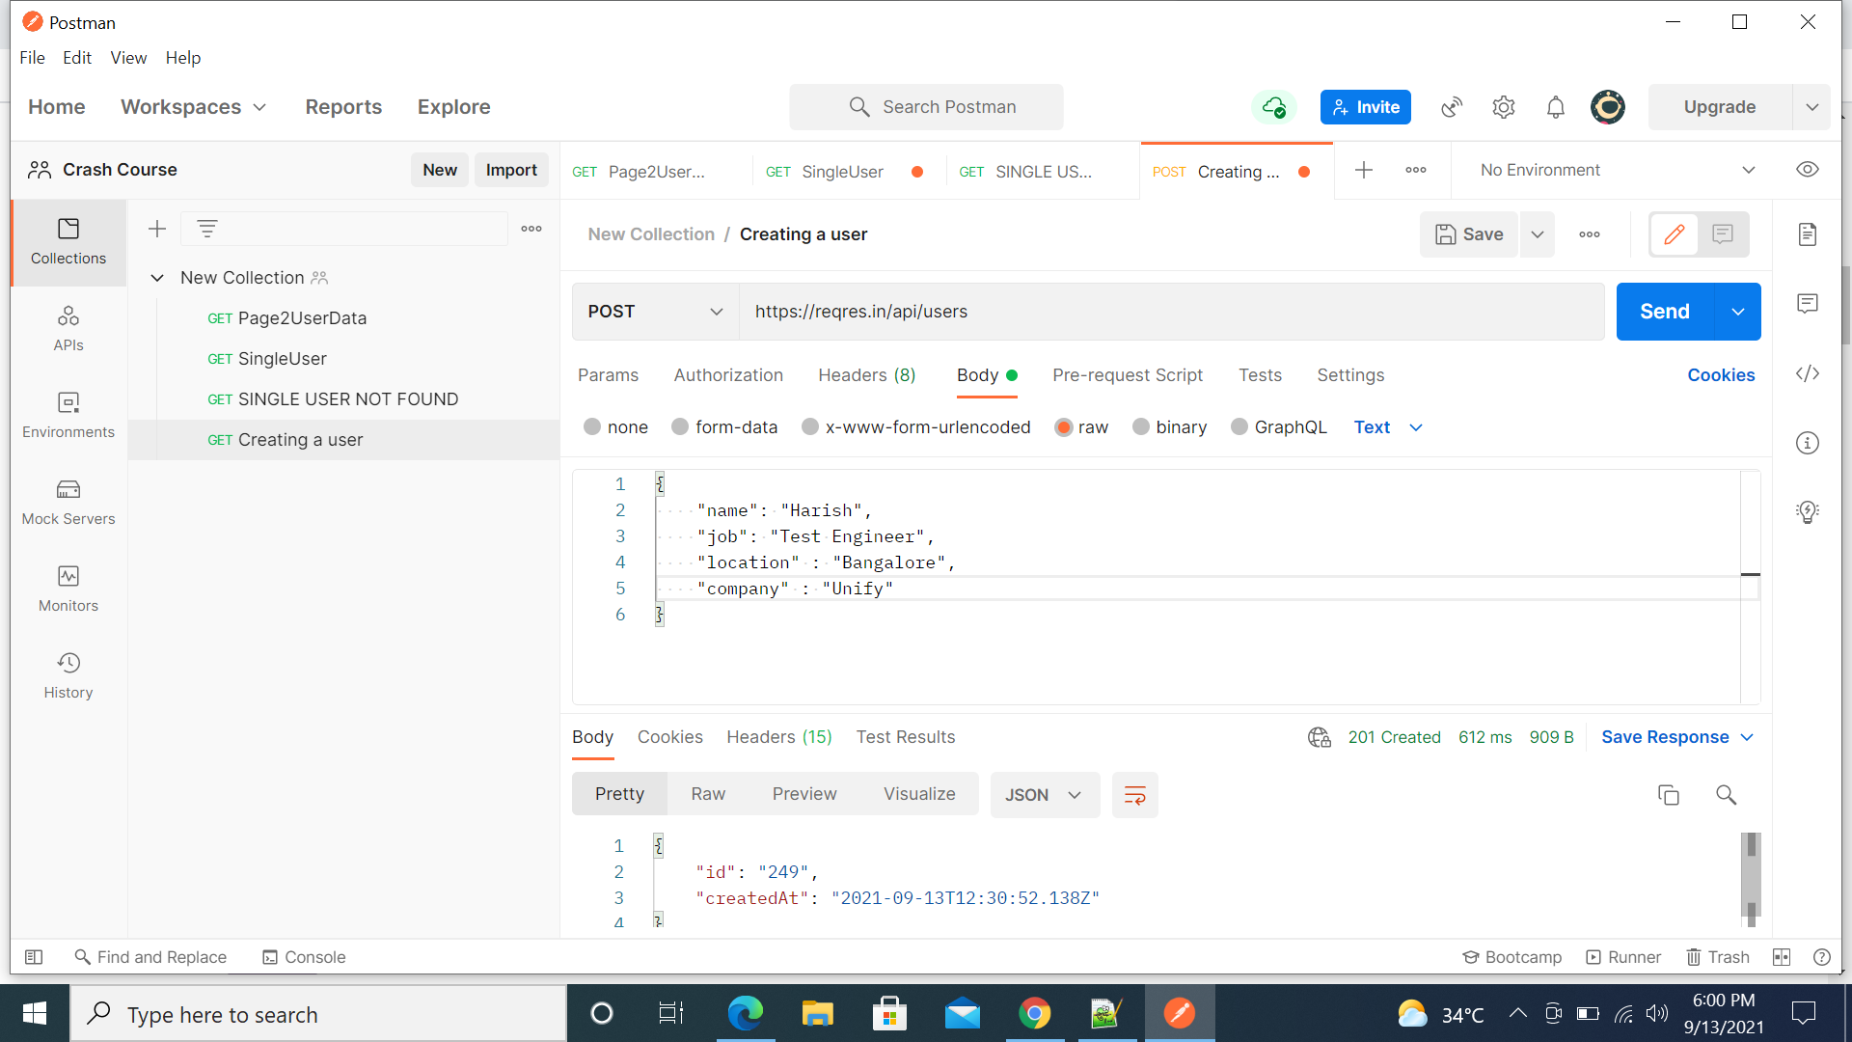

**Validate the response of POST request**

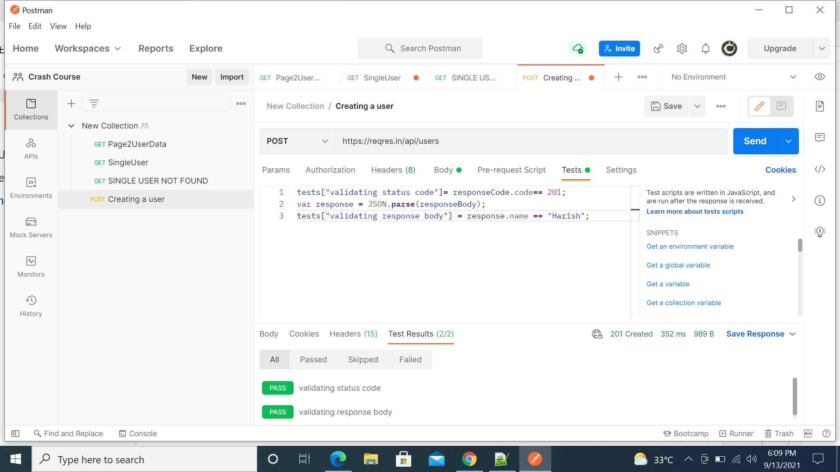

**User Authentication**

*Whenever user creates a login, the userid and password details will be stored in an API*

*Post that API will send that details to server and server will verify the request and sends a token*

*Now based on the Token, API will decide whether the user is allowed to login or not*

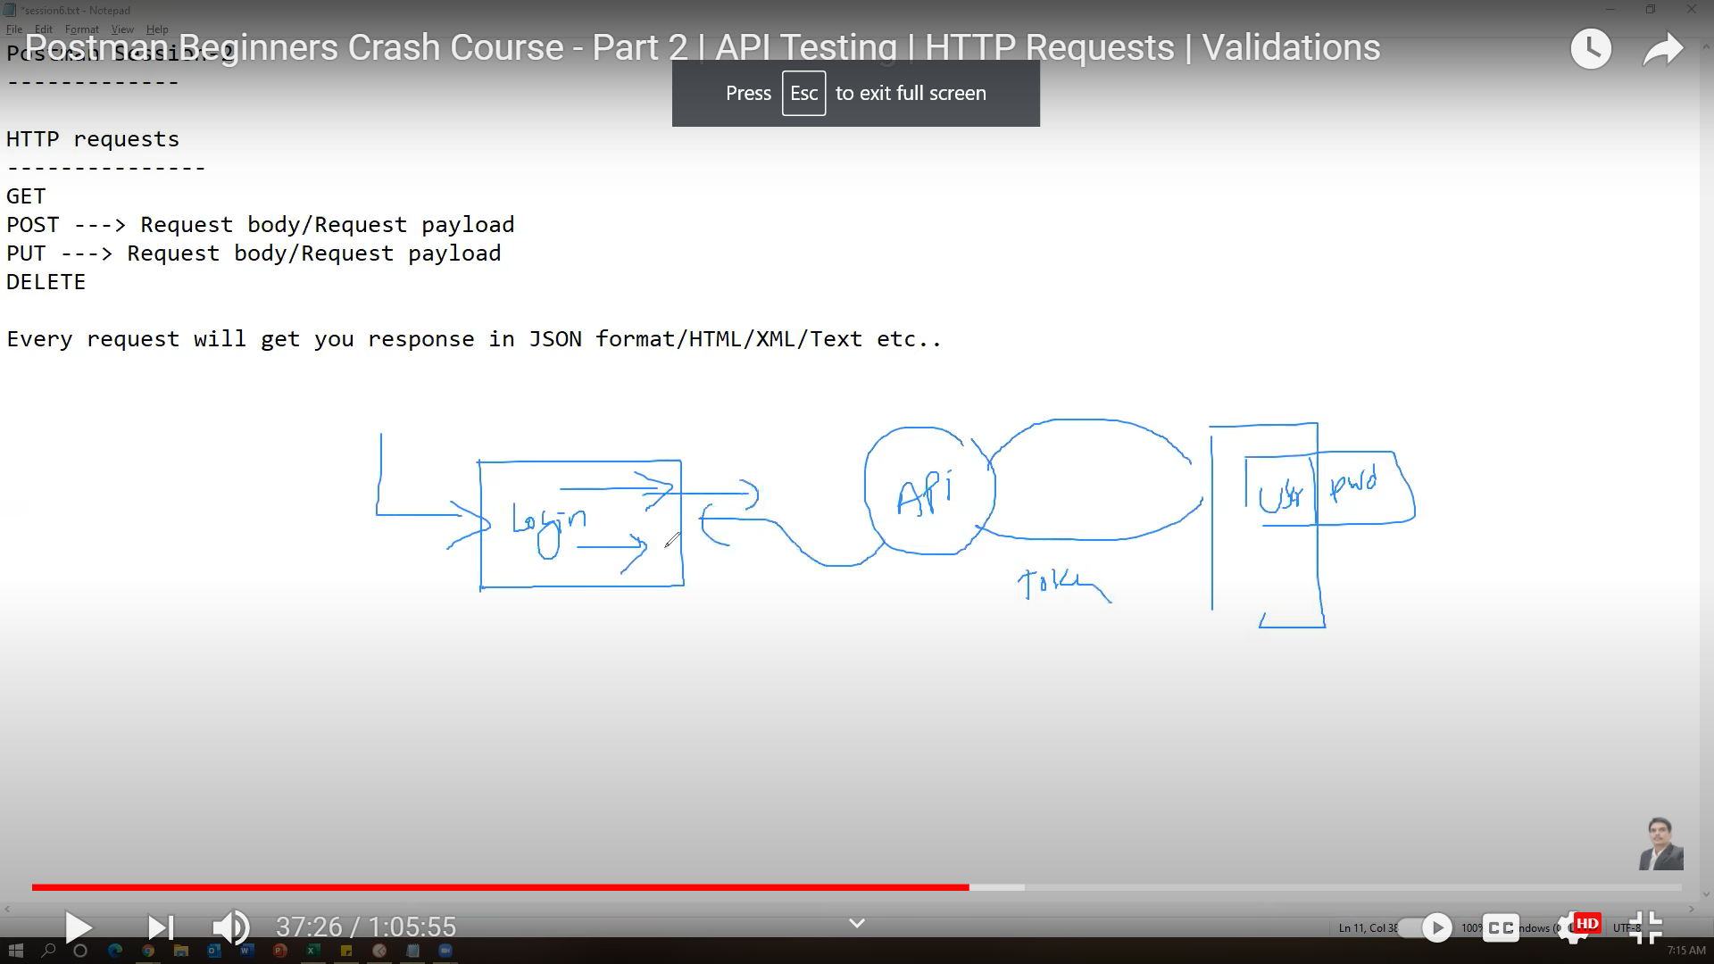

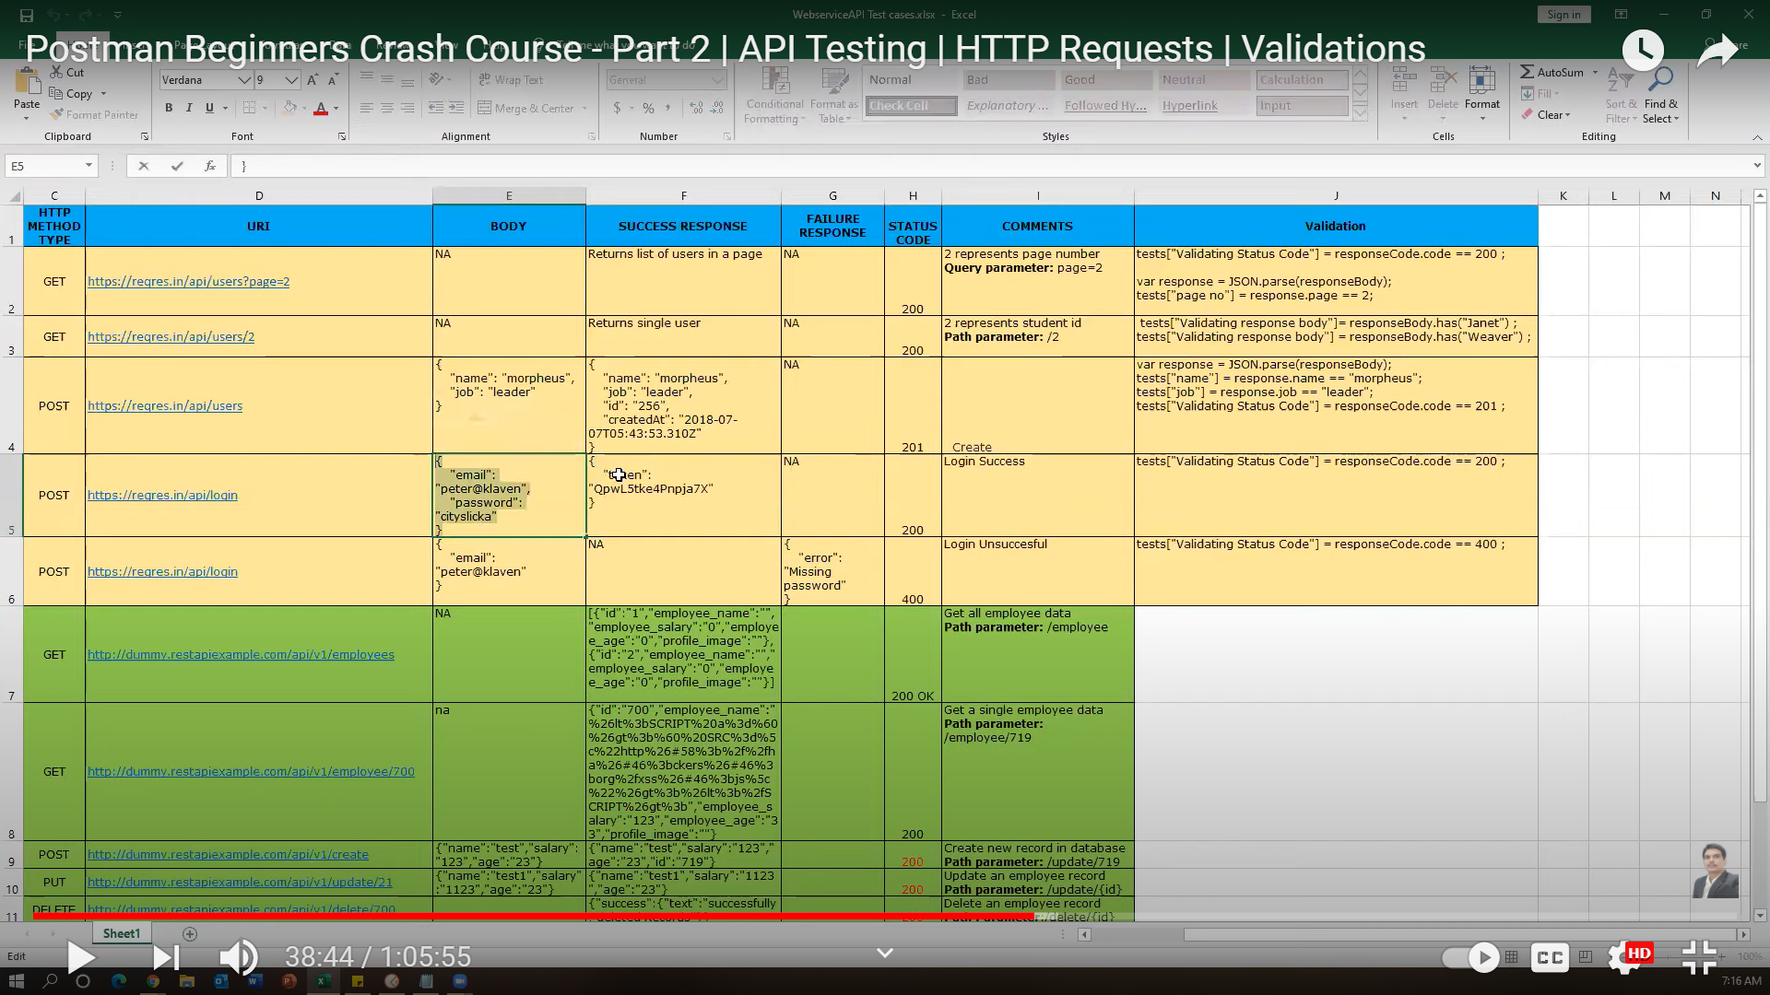

**2 Scenarios login successful and unsuccessful**

**Login not Successful**

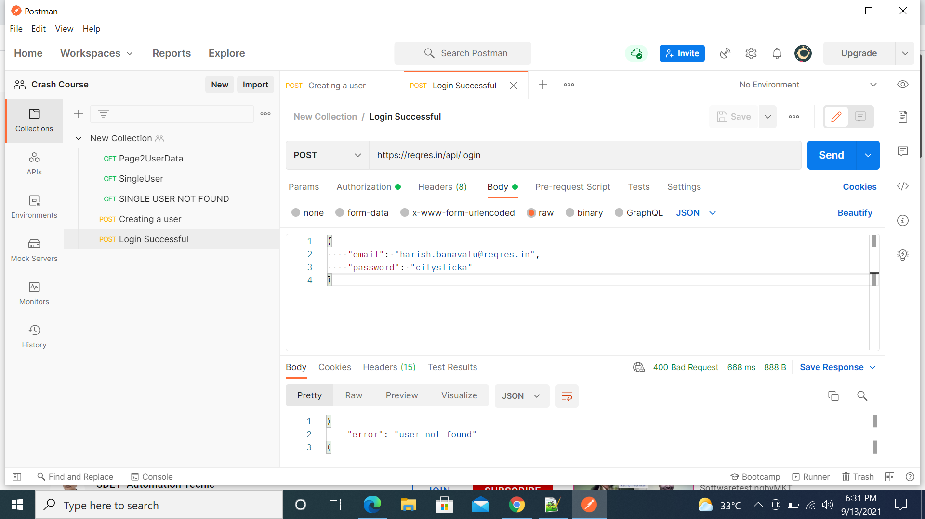

**Now, sending the valid data**

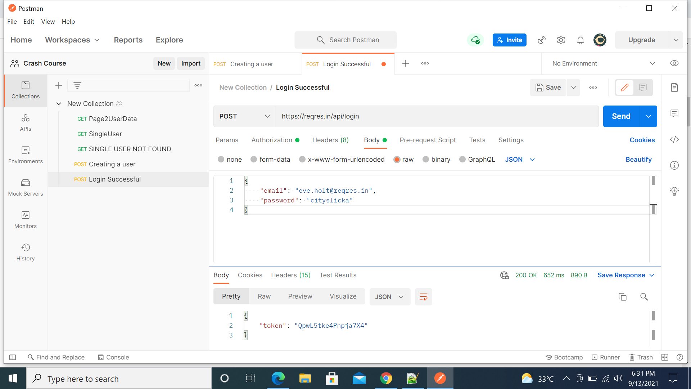

**Token is generated randomly and we can check token is available or not**

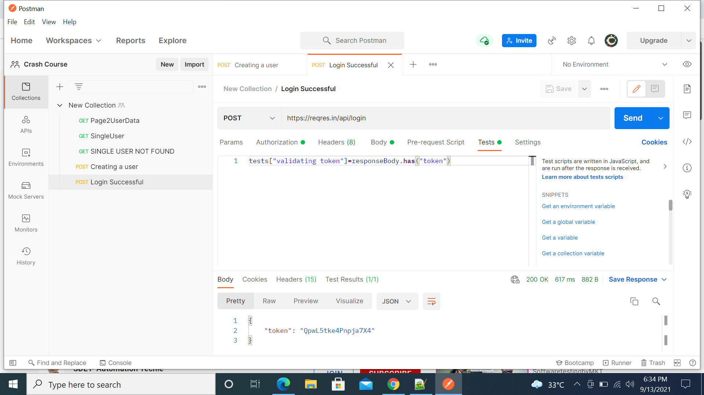

**Incomplete details**

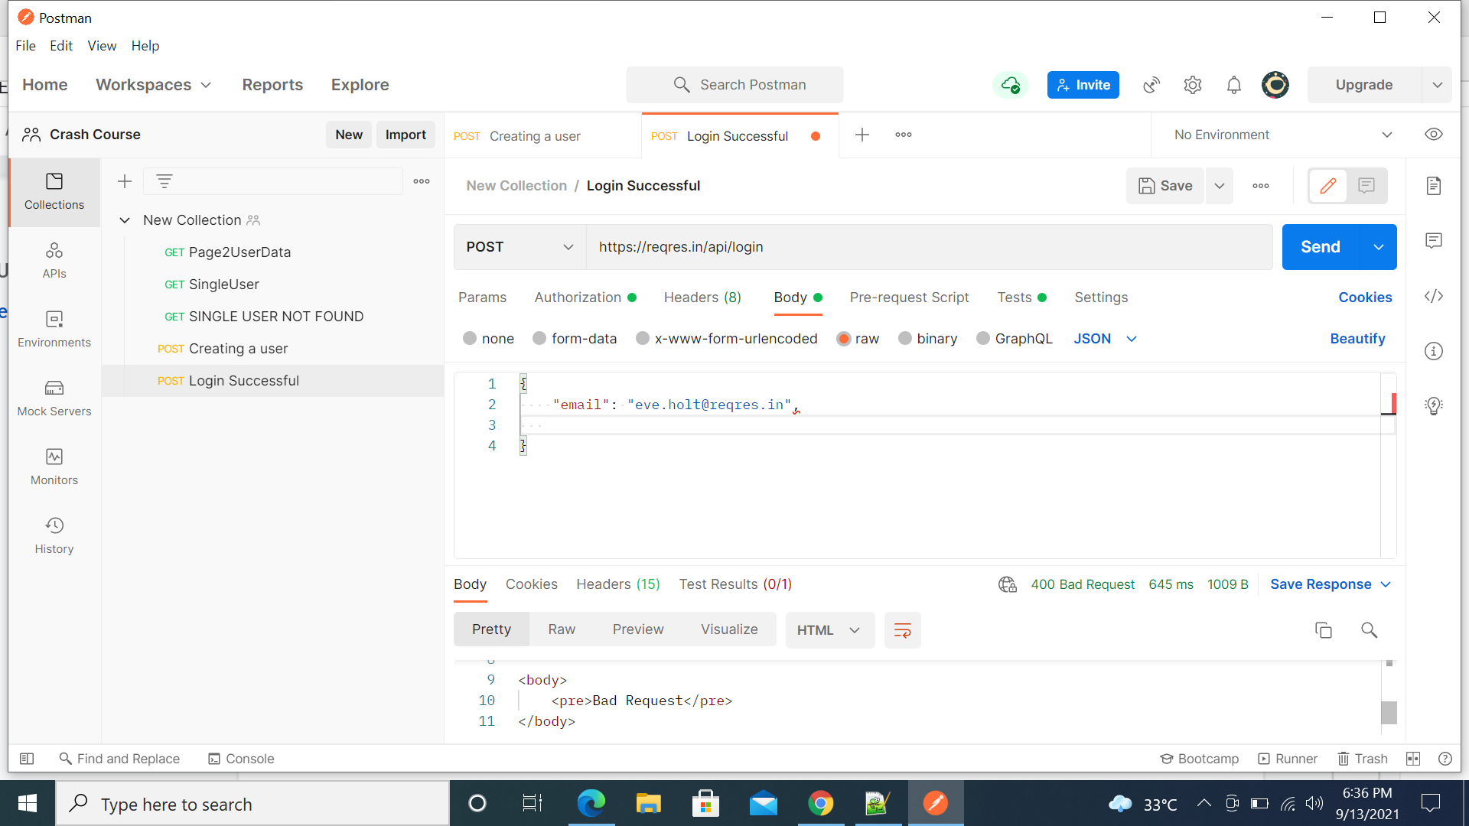

**DELETE**

